**IPU-CSL 444 (S23) Programming Assignment – 2**

Solve any five questions out of six. Each question reserved 3 marks. Evaluation date: 14.4.2023

**1Q.** Implement a function Count_hole( ) that takes a black and white image (imghole.jpg) as input and returns number of holes in that image. Use morphological and logical operations in the Count_hole() function implementation.

**2Q. Implement a program that uses thresholding and morphological operations to segment the organ of interest in the given CT image, abdomen.jpg. Organs of interest are shown in the below image.**

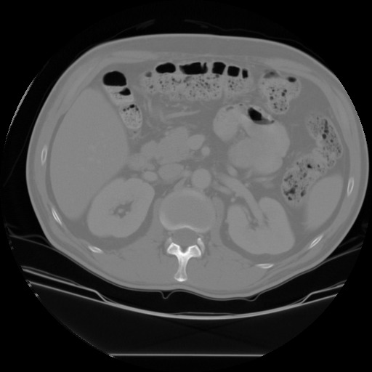 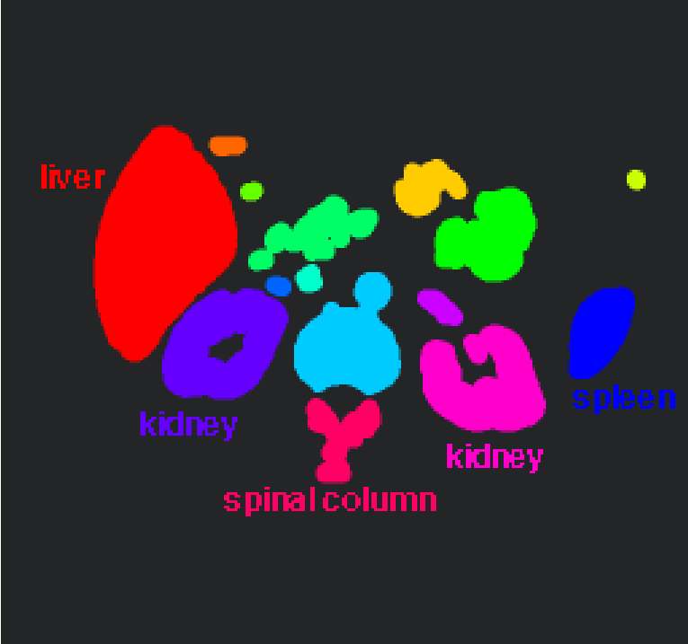

a) Input image (abdomen.jpeg) b) Output image

**3Q.** Implement your own program to detect number of circles in the image disks.png using the circle Hough transforms method and compare the obtained output with built-in function output.

**4Q.** Implement a program to detect moving vehicles by using median differencing background subtraction technique and mention your observations on the result. Use **traffic.3gp** video clip to test your code.

**5Q.** Write a program to perform robust image matching using RANSAC algorithm and Harris Corner features. Use **FM_img1.jpg** and **FM_img2.jpg** to test the program.

**6Q.** Write a program to implement Otsu’s algorithm for global threshold-based image segmentation. Use **Boat_Otsu.png** image to test your code.